**Auto Running Application In Intellij IDEA**

1. we should have a dev tool maven dependency in our pom.xml file

<dependency>  
 <groupId>org.springframework.boot</groupId>  
 <artifactId>spring-boot-devtools</artifactId>  
 <scope>runtime</scope>  
 <optional>true</optional>  
</dependency>

1. File->settings->Build, Execution, Deployment->Compiler

Select the checkbox of **Build project automatically**

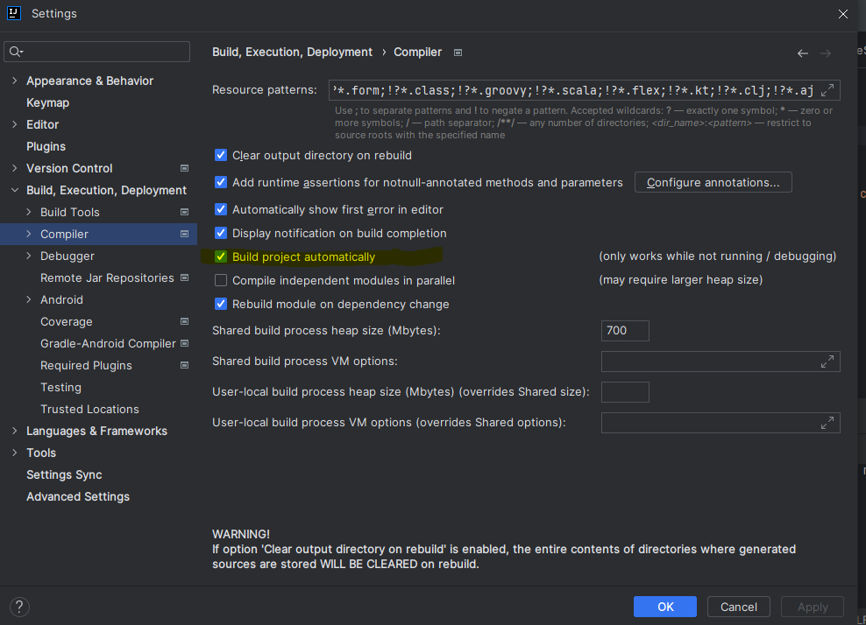

1. file->settings->Advanced Settings

Select the check box of **Allow auto-make to start even if developed application is currently running**

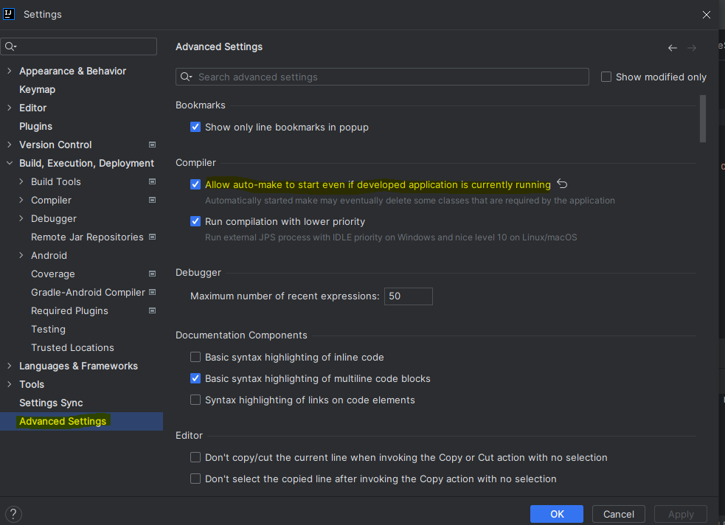

1. Restart the server, make changes and wait for some time next hit the url